
Dressing for forest school
Forest school happens in all weathers and in all seasons, so being dressed appropriately is essential.
It is important that the clothes your child wears will protect them from the weather and activities as well as protecting them against the natural environment such as insect bites and stinging nettles.
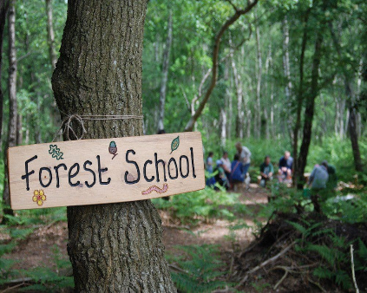
In colder months we recommend layering clothes such as wearing a vest or thermal under a long sleeved top and bringing a spare pair of socks for wearing boots, a warm coat, hat and gloves.
Waterproof trousers and coats are provided by school, however we advise your child has a thicker, warmer coat in school due to the school coats being thin.
Below is a guide for how to best dress and prepare your child for forest school.
First layer | Second layer | Third layer | Provided by school
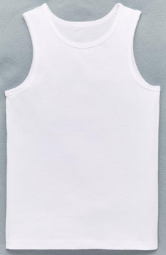  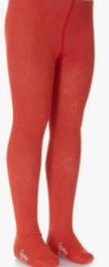  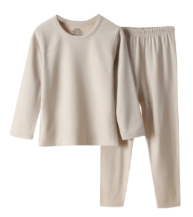 | 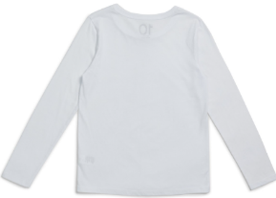  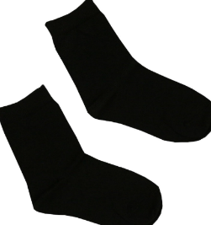  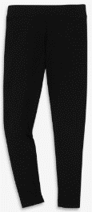  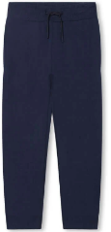  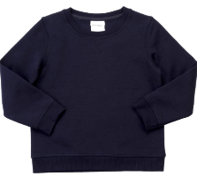 | 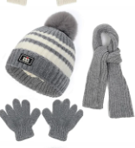  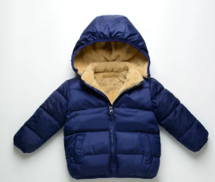  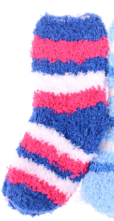  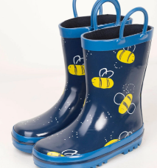 | 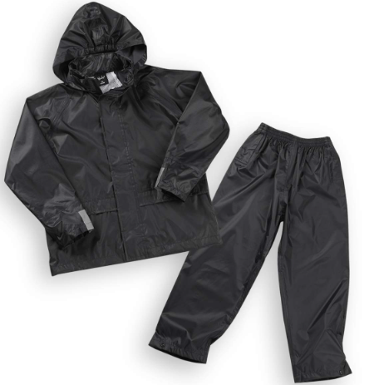
A vest, thermal and tights. | Leggings or jogging bottoms, long sleeved top, jumper and socks | Thick socks, wellies, warm coat, hat scarf and gloves. | Water proofs – coat and trousers
Winter

Summer
First layer | Second layer | Third layer | Provided by school
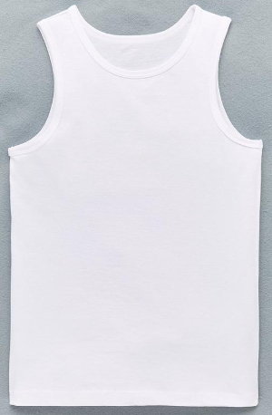 |  | 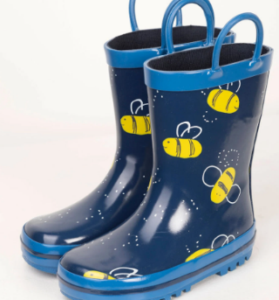 | 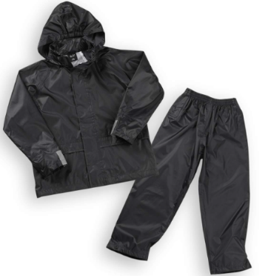
A vest | Leggings or jogging bottoms, long sleeved top and socks | Wellies. | Water proofs – coat and trousers

